Wednesday 5th August 2020 Oswald, King of Northumbria

Dear Friends

August is a busy month for church commemorations. Tomorrow we celebrate the Transfiguration (also Hiroshima Day of course) and on Sunday we remember Mary Sumner, the founder of the Mothers’ Union. Ironically though, commemorations that fall on a Sunday are ignored in the church calendar in preference for the proper liturgical celebration – though I am sure with the help our own Mothers’ Union, we’ll find a way around this come Sunday!

Today, the church remembers Oswald, one of the great Celtic Kings of the North. Oswald died in battle on this day in the year 642; that this fact is known at all gives us an indication of his standing.

Oswald was baptised on Iona by the monks of St Columba and was a great friend of St Aidan. The night before his great defeat of the English King, Oswald set up a cross as his standard and gathered his men around it to pray. Whatever we might think of that in today’s more rational age, it is a sign of his faith and fear.
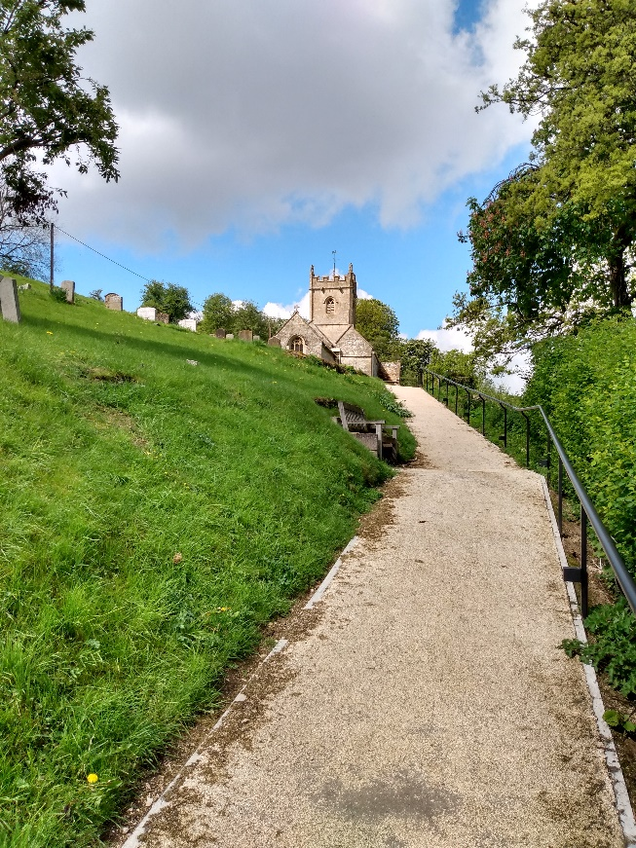
In my last benefice, one of the smaller village churches (total population of the parish = 87) was dedicated to St Oswald.

The parish church of Compton Abdale is reached up a very steep climb and upon arrival one is greeted by wonderful views combined with a stiff breeze. The church is beautifully cared for but absolutely freezing cold even with the heating full on. The church’s ring of four bells ensure the service is well publicised across the valley – but the stiff climb means that only the fittest, most determined or most foolish, make it to worship.

On Sunday last over 70 people gathered for worship online or physically present in All Saints Church. We marked our ‘return’ with a celebration of friendship, surely the most important of gifts that has carried us thus far through the pandemic. We’ve reviewed how everything worked and, with small improvements, I am sure we can continue to worship in church despite the differences and the challenges. Unlike churches like St Oswald which are so inaccessible to many in ordinary times, leave alone today, our worship on Sunday was available to all. That matters so much – for no one is beyond the love of God.

This week’s newsletter contains a number of new items so please do read it carefully. In addition, I’m delighted to report that St Joseph’s will return for their monthly Orthodox service in All Saints on the 6th September. Thankfully their community has been largely unaffected by the virus and we pray that may continue. We are also working hard to re-open our church halls beginning with a trial re-opening at St Godwald’s from this week. There is a lot for churches and hirers to think through and plan for – but again, with determination and grace, we’ll get there.

As part of this mailing this week I hope you will receive a statement from the support group for asylum seekers that has been established in Bromsgrove following the arrival of a group of asylum seekers at a hotel in Catshill. Sadly, this development has made manifest the latent racism that exists in parts of our community. I urge you to read the statement, support the work that people of goodwill are trying to do to support the asylum seekers and please speak up against racism whenever you experience it.

It is a fundamental Christian principle to support in active practical ways all who are marginalised by our culture:

For the Lord your God is God of gods and Lord of lords, the great God, mighty and awesome, who is not partial and takes no bribe, who executes justice for the orphan and the widow, and who loves the strangers, providing them with food and clothing. You shall also love the stranger, for you were strangers in the land of Egypt. (Deut. 10.17-19)

In different ways and at different times we have all experienced exclusion and rejection. Now embraced by faith in the love of God, it is our duty to extend that embrace to all.

This letter comes, as always, with my love and prayers:

David Ford, Rector

01527 873831 revdavidford@googlemail.com

