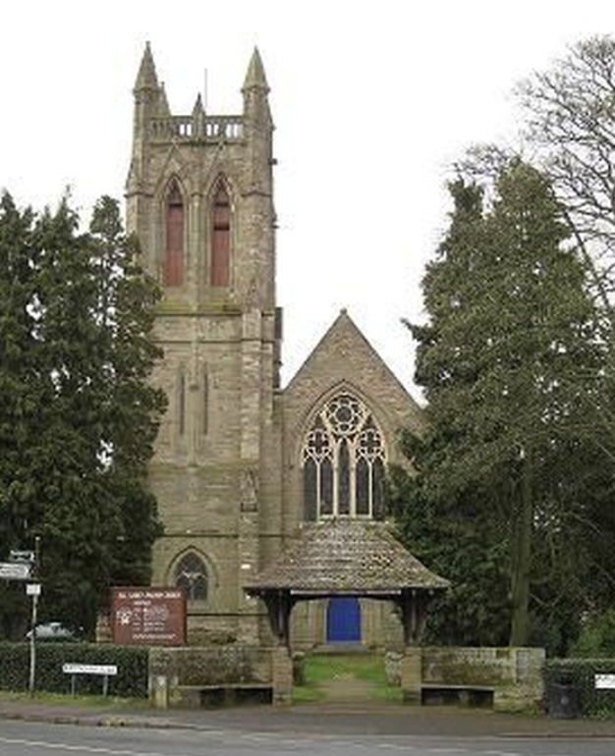
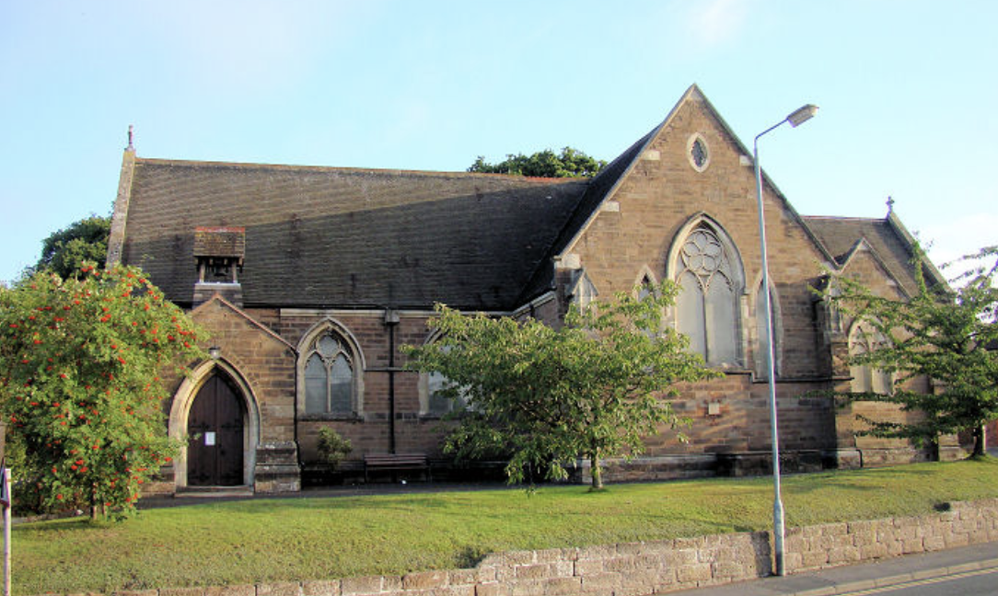

ALL SAINTS’ AND ST GODWALD’S

SUNDAY 27th July 2025
The Sixth Sunday after Trinity

Prayer for the Week
Creator God,
you made us all in your image:
may we discern you in all that we see,
and serve you in all that we do;
through Jesus Christ our Lord.

Saturday 26th July:
5.00 pm St Godwald’s Pizza Church led by Rev’d Ann Cogle and Katherine Downey

Sunday 27th July: The Sixth Sunday after Trinity
9.00 am St Godwald’s: Morning Prayer led by Caroline Spencer and Norman Hewer
10.30 am St Godwald’s: Morning Worship led by Judith Rowe and Emma Morris
10.30 am All Saints’: Holy Communion (CW)
https://us02web.zoom.us/j/9408514608
Zoom ID: 940 851 4608
Passcode: 6TAy1V

Next Week’s Services:

Sunday 3rd August: The Seventh Sunday after Trinity
8.00 am All Saints’: Said Holy Communion (CW) led by Rev’d Sue Humphries.
10.30 am St Godwald’s: Joint Holy Communion (CW) with All Saints’ led by Rev’d Ann Cogle

SOUL AND SENSES SERVICE
This is a Service at All Saints’ Church held on the first Saturday of each month at 5.00pm.
Each Service lasts for around 40 minutes and includes reflective prayer, music and poetry.
Please come and join us in wondering and exploring what God is saying to and with us. All are very welcome for a time of quiet and reflection.
The next service will be on Saturday 6 September at 5pm. (There will not be a service in August).

PIZZA (CAFÉ) CHURCH
Café Church is an informal service in the Church Hall at St. Godwald's for all the family to enjoy. A small buffet style supper is included. The next Pizza Church is on Saturday, July 26th at 5pm (and every last Saturday of the month).

Fr DAVID LINGWOOD
Fr David Lingwood's sermons, are available online at:
www.youtube.com/@Fr.David.TSSF-HorribleHomilies/videos
or by searching for 'Horrible Homilies' on YouTube.
Each is about 7 minutes long and is a multimedia presentation.

ST GODWALD’S

TOTWALDS
Totwalds is our worship time in church for 0-5 year-olds and their parents/carers. There is always a story, lovely songs and an activity.
Everyone is welcome at 9.30am each Monday morning.
We are now on our Summer Break, but will return on 8th September

TUESDAY WALKS meet on 2nd and 4th Tuesdays.
Please note that the next walk is on 12th August 2025 at 10.00 am starting from the Ruth Heald Room and returning at 12 noon for refreshments.

WEDNESDAY MORNING SERVICE
Join us in the Ruth Heald Room at 10.00 am for Worship followed by refreshments.
There will be two Communion Services each month and two services of Morning Worship.


ST GODWALD’s COMMUNITY CAFÉ
The Community Café is open every alternate Friday. The next cafés will be Friday 1st August and Friday 15th August 2025 10.00 am until 12.30 pm.
No charge but donations always very welcome.

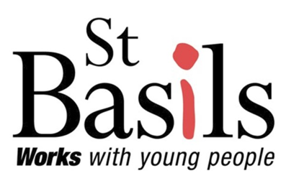
ST BASILS
St Basils is a homeless shelter in Bromsgrove.
It works with young people aged 16-25 who are homeless or at risk, helping almost 4000 youngsters per year across the West Midlands.

Thank you very much for your continued support of the Community Café and Ramble Group; the fellowship and fundraising are instrumental in raising money for St Basils.

STRAWBERRY CREAM TEA
The Society of the Friends of St Godwald would like to sincerely thank all who supported, in any way, the Strawberry Cream Tea and Plant Sale held last Saturday in the Church Hall which raised £500.00.


CHURCH CLEANING at ST GODWALD’S

Our next session of communal church cleaning will be on Friday 25th July from 10am, followed by tea or coffee in the Ruth Heald Room.
All Welcome!

FOR YOUR PRAYERS:

Margaret Woodgates and Rhoda

The Christian Union at South Bromsgrove High School
Please pray for the youngsters and for the termly online prayer meetings that are held to support the school.
Please include our schools – first, middle and high – in our prayers.

ALL SAINTS’

CHATTERY
Meetings are held weekly on Wednesdays in All Saints’ Church Hall from 2.00 to 3.30 pm.
It is a warm, friendly group of a wide range of ages. Further details from Tessa Carrick on 01527 873135.

CHOIR PRACTICES: Most weeks the choir rehearsals are on Thursdays from 5.30 pm to 7.00 pm. *NOT IN AUGUST*
Members of the Choir are asked to be at church on 2nd, 3rd and 4th Sundays by 9.50 am for practice before the 10.30 am services. Please contact Ollie Neale regarding the choir and music and to confirm times of practices: ollie.neale@hotmail.co.uk

If you enjoy listening to All Saints’ Choir at Services you might like to see this schedule:

1st Sunday of the month: The Choir join the 10.30am Joint Service at St Godwald’s, Holy Communion with Hymns, (with organist Joel Pagett)
2nd Sunday of the month: 10.30am Joint Service at All Saints’ with St Godwald’s. The 'Main' Choral Service of the month where we might have a more complex Anthem/Service Music etc.
3rd Sunday of the month: 10.30am Lay-Led Service-only Hymns.
4th Sunday of the month: 10.30am Holy Communion-Mass Setting, Anthem and Hymns.
5th Sunday of the month: 10.00am Team Service ONLY if at All Saints’ Church


MOTHERS’ UNION
The Mothers’ Union will meet on the third Monday of each month at 2.30pm at 12, Chapel Street, Bromsgrove. At each meeting there is a short time of worship, a speaker and refreshments. All are welcome.

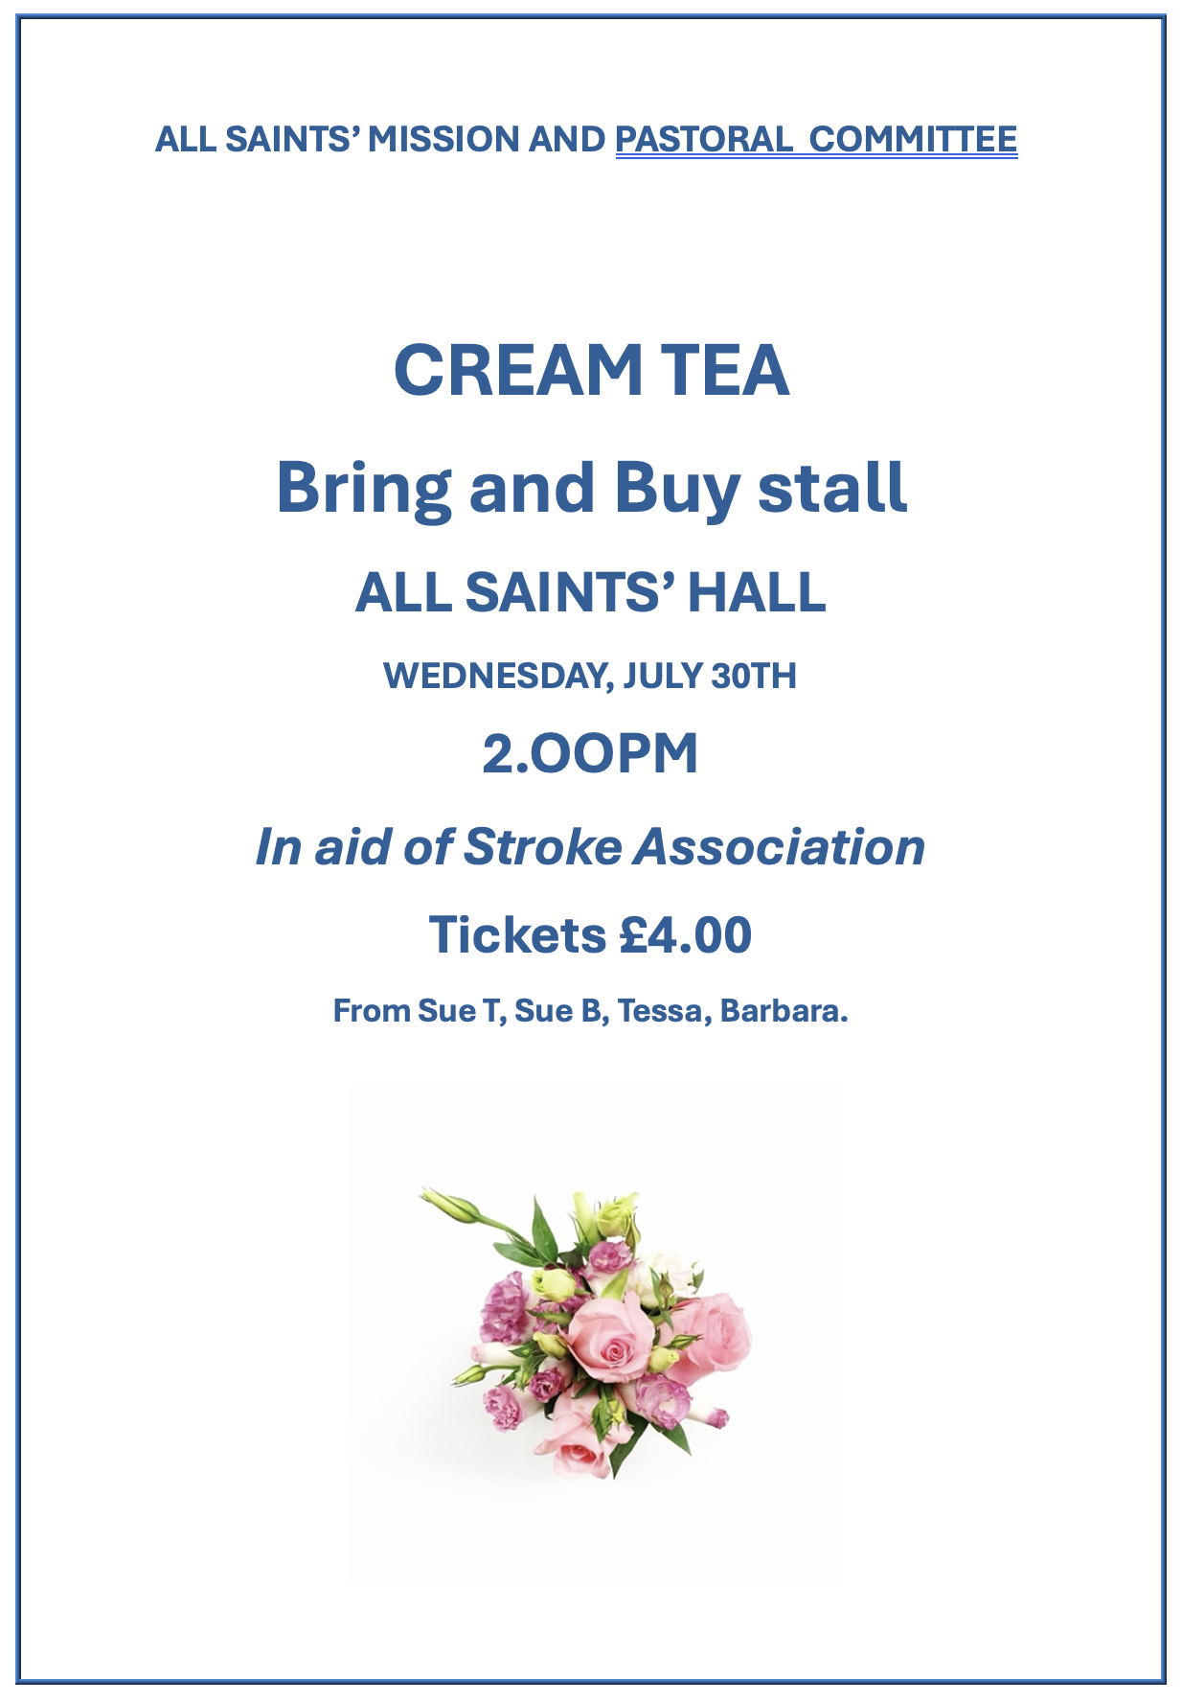

POSTAGE STAMPS

USED POSTAGE STAMPS FOR THE RNIB (Royal National Institute of Blind People)


A very BIG THANK YOU to all who continue to donate stamps for this Appeal. Stamps can be brought to church during any of our services, there is a box on the table at the back, or to the Parish Office, during opening hours. There is no cost to the church for sending these to the RNIB, and it is a really good way of recycling our stamps and raising funds for the RNIB - £20.00 per kilo. In total, during 2024, the RNIB raised over £20,000 from the stamps collected around the country, so it is well worthwhile and much appreciated. If you have any queries about this, then please call
Gill Gould (All Saints on 07824368584).
THANK YOU AGAIN AND PLEASE DO KEEP COLLECTING THEM 😊


THE BASEMENT PROJECT
Please remember to keep supporting the Basement Project.
More information at
www.basementproject.org.

DATES for your DIARIES

Wednesday 30th July: All Saints’ Cream Tea at 2.00 pm in All Saints’ Hall
Tickets £4.00

Sunday 7th September: Licensing of the Revd. Dr. Alan Conant, 4.00pm at St. Godwald’s Church

Saturday 13th September: Heritage Weekend at All Saints’ – more
Sunday 14th September: details later

Saturday 29th November: All Saints’ Christmas Bazaar will be taking place on from 2.00 pm to 4.00 pm in the Church Hall.

MONTHLY PATTERN of SERVICES at All Saints’ and St Godwald’s:

1st Sunday: 8.00 am Holy Communion CW at All Saints’
10.30am Joint Holy Communion CW at St Godwald’s

2nd Sunday: 9.00am Holy Communion BCP at St Godwald’s
10.30 am Joint Holy Communion CW at All Saints’

3rd Sunday: 8.00 am Holy Communion CW at All Saints.
10.30am Holy Communion CW at St Godwald’s
10.30 am Morning Worship at All Saints'.

4th Sunday: 9.00 am Morning Prayer at St Godwald's
10.30 am Holy Communion CW at All Saints’.
10.30 am Morning Worship at St Godwald's.

5th Sunday: Team Service in various churches.

First Saturday: 5.00pm Soul and Sense at All Saints’
Last Saturday: 5.00pm Café/Pizza Church at St Godwald’s

St Godwald’s and All Saints’ Services for AUGUST:

Sunday 3rd August: The Seventh Sunday after Trinity
8.00 am All Saints’: Said Holy Communion (CW) led by Rev’d Sue Humphries.
10.30 am 10.30 am St Godwald’s: Joint Holy Communion (CW) with All Saints’ led by Rev’d Ann Cogle

Sunday 10th August: The Eighth Sunday after Trinity
9.00 am St Godwald’s: Holy Communion (BCP) led by Rev’d Ann Cogle
10.30 am All Saints’: Joint Holy Communion (CW) with St Godwald’s

Sunday 17th August: The Nineth Sunday after Trinity
8.00 am All Saints’: Said Holy Communion led by Rev’d Sue Humphries.
10.30 am St Godwald’s: Holy Communion (CW) led by Rev’d Ann Cogle
10.30 am All Saints’: Morning Worship - led by Pam Rosewarne and Sue Ward.

Sunday 24th August: The Tenth Sunday after Trinity
9.00 am St Godwald’s: Morning Prayer led by Caroline Spencer and Norman Hewer
10.30 am St Godwald’s: Morning Worship led by Judith Rowe and Emma Morris
10.30 am All Saints’: Holy Communion (CW)

Saturday 30th August:
5.00 pm St Godwald’s Pizza Church led by Rev’d Ann Cogle and Katherine Downey

THE REDDITCH MISSION AREA

The Redditch Mission Area is looking for a dynamic, highly competent Operations Manager.

The aims of the Redditch Mission Area (RMA) are to support the 12 diverse parish churches across Greater Redditch (including Alvechurch, Feckenham and Tardebigge) helping them flourish as unique places where God is worshipped and communities are served, so they are able to express what God is calling them to be and for them to be healthy and sustainable in living this out. We want our local churches to demonstrate the breadth of worship in the Church of England; a variety of worship held together by a shared faith in God, Father Son and Holy Spirit. Our hope is that blessed and directed by God’s Holy Spirit we can live out our calling to Facilitate, Enable and Share in God’s Mission Across Greater Redditch.

The Operations Manager will be a pivotal strategic partner to the RMA Leader, driving the operational and administrative backbone of the Redditch Mission Area. This role demands an entrepreneurial self-starter with a strategic mind, focused on ensuring robust governance, optimal efficiency, and seamless operational infrastructure. This role strategically enables the mission area and its churches to focus on their outwardlooking ministry and mission by expertly managing the internal environment. There is also a need to look at what the RMA delivers to the churches of the area but supporting the other RMA staff and working the Mission Area Leader and others to provide practical support or leverage opportunities to share in areas of work across the area.

For further details and full application pack go to www.cofe-redditch.org.uk/jobs/ Email: info@cofe-redditch.org.uk Applications Close:

Salary: £31294 pa + 5% employers pension contribution Full Time: 37.5 hours per week ﬁxed term post of 3 years

Annual Leave: 25 days per annum, plus statutory public holidays.



CONTACT DETAILS:

Lauren Jones – Parish Administrator
(For all enquiries including the booking of Church Halls)
St Godwald’s Office: 01527 577759 pa.bromsgroveparish@gmail.com
Please scan below to check the Parish Office opening hours for this week:


All Saints’ Church Wardens:
Sue Ward 0121 453 3180 and Sue Bryant 01527 835728
St Godwald’s Church Wardens:
Caroline Spencer 01527 832414 and Norman Hewer 01527 871722
All Saints’ Organist and Choirmaster
Ollie Neale, email: ollie.neale@hotmail.co.uk

SAFEGUARDING
All Saints’ Safeguarding Lead:
Gill Gould 07824 368584
St Godwald’s Safeguarding Lead:
Catherine Maund 07788 418045
Diocesan Safeguarding Advisor:
Hilary Higton 07495 060869

The Diocese of Worcester, All Saints DCC and St Godwald’s DCC are all committed to promoting a Safer Church for everyone. We will seek to promote the welfare of children, young people and adults, work to prevent abuse from occurring, protect those that are at risk of being abused, and respond well to those that have experienced abuse.

***Information for the Newsletter: Please let me have any news or items for the next Newsletter from either St Godwald’s or All Saints’
by 12 noon on Tuesday, Thank you, Catherine Maund: cmaund1@sky.com

