
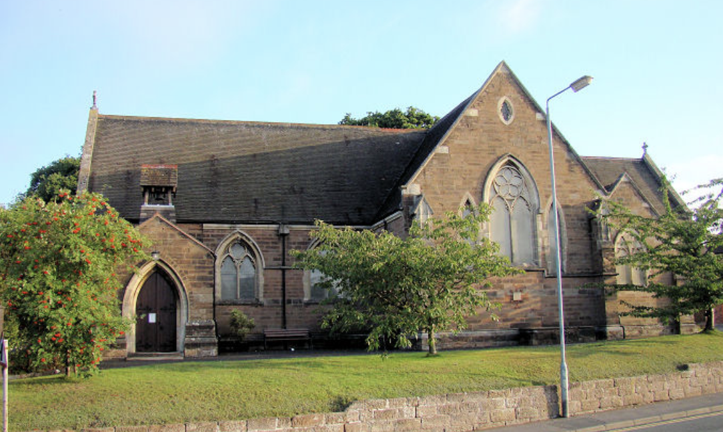
ALL SAINTS’ AND ST GODWALD’S

SUNDAYS 9th, 16th, 23rd
MARCH 2025

Prayer for the Week
Sunday 9th March: The First Sunday of Lent
Heavenly Father,
your Son battled with the powers of darkness,
and grew closer to you in the desert:
help us to use these days to grow in wisdom and prayer
that we may witness to your saving love
in Jesus Christ our Lord.

Sunday 9th March: The First Sunday of Lent
9.00 am St. Godwald’s: Holy Communion (BCP) led by Rev’d Ann Cogle

10.30 am All Saints’: Joint Holy Communion (CW) with St Godwald’s led by Fr David Lingwood
https://us02web.zoom.us/j/9408514608
Zoom ID: 940 851 4608 Passcode: 6TAy1V

4.00 pm Holy Trinity & St Mary’s Church Dodford: The licensing of the Reverend Amanda Arthur as part time Team Vicar in the Benefice of Bromsgrove.

Prayer for the Week
Sunday 16th March: The Second Sunday of Lent
Almighty God,
by the prayer and discipline of Lent
may we enter into the mystery of Christ’s sufferings,
and by following in his Way
come to share in his glory;
through Jesus Christ our Lord.

Sunday 16th March: The Second Sunday of Lent

8.00 am All Saints’: Said Holy Communion led by Rev’d Sue Humphries.
10.30 am St. Godwald’s: Holy Communion (CW) led by Rev’d Ann Cogle
Unfortunately, there will be no zoom for this service.
10.30 am All Saints’: Morning Worship - led by Pam Rosewarne and Sue Ward.

Prayer for the Week
Sunday 23rd March: The Third Sunday of Lent
Eternal God,
give us insight
to discern your will for us,
to give up what harms us,
and to seek the perfection we are promised
in Jesus Christ our Lord.

Sunday 23rd March: The Third Sunday of Lent

9.00 am St. Godwald’s: Holy Communion (BCP) led by Rev’d Deb Buckley
10.30 am St Godwald’s: Morning Worship led by Judith Rowe and Emma Morris
10.30 am All Saints’: Holy Communion (CW) led by Rev’d Deb Buckley
https://us02web.zoom.us/j/9408514608
Zoom ID: 940 851 4608 Passcode: 6TAy1V

DEANERY SYNOD
The next Deanery Synod meeting is at St Peter's Church, Ipsley on Wednesday 12th March at 7.30pm and is open to all. The guest speaker will be Archdeacon Mark Badger, who will be speaking about 'Mindfulness'.
If you are interested in going, please speak to Revd Ann as we have been asked to give an indication of numbers - and we may be able to arrange to car share.

SOUL AND SENSES SERVICE
This is a Service at All Saints’ Church held on the first Saturday of each month. The next service is on Saturday 5th April at 2025.
Each Service starts at 5.00pm and lasts for around 40 minutes.
Please come and join us in wondering and exploring what God is saying to and with us. All are very welcome for a time of quiet and reflection.

PIZZA (CAFÉ) CHURCH
Café Church is an informal service in the Church Hall at St. Godwald's for all the family to enjoy. A small buffet style supper is included. The next Pizza Church is on Saturday, March 29th at 5pm (and every last Saturday of the month).

Fr DAVID LINGWOOD
Fr David Lingwood's sermons, are available online at:
www.youtube.com/@Fr.David.TSSF-HorribleHomilies/videos
or by searching for 'Horrible Homilies' on YouTube.
Each is about 7 minutes long and is a multimedia presentation.

WORLD DAY OF PRAYER

World Day of Prayer from The Cook Islands 2025 will be held at Bromsgrove Baptist Church on 7th March at 11.30 am all are welcome – for more information please contact Jan Hewer.

ST GODWALD’S

TOTWALDS
Monday 10th, 17th, 24th March at 9.30am
Totwalds is our worship time in church for 0-5 year-olds and their parents/carers. There is always a story, lovely songs and an activity.
Everyone is welcome.

TUESDAY WALKS meet on 2nd and 4th Tuesdays.
Please note that the next walks are on 11th and 25th March 2025 at 10.00 am starting from the Ruth Heald Room and returning at 12 noon for refreshments.

WEDNESDAY MORNING SERVICE
Join us in the Ruth Heald Room at 10.00 am for Worship followed by refreshments.
There will be two Communion Services each month and two services of Morning Worship.

ST GODWALD’s COMMUNITY CAFÉ
The Community Café is open every alternate Friday. The next café will be Friday 14th March 2025 10.00 am until 12 noon.
No charge but donations always very welcome.

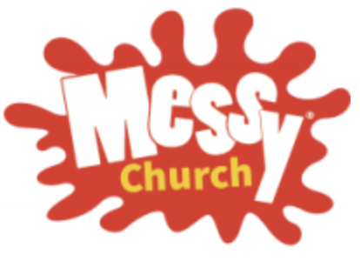
EASTER MESSY CHURCH
We are planning once again to hold an Easter Messy Church on Good Friday morning, 18th April. Please put the date in your diary. Revd Ann would be very happy to hear from you if you would be willing to help with activities or refreshments on the day.

ELECTORAL ROLL
This is a big year for the Church Electoral Roll! Every 6 years we have to ‘start again’, it doesn’t matter who was on the roll previously, everyone is taken off, and everyone has to re-apply. Being on St Godwald’s electoral roll gives you church voting rights, it does not unfortunately bring in more money for the church, but it does help St Godwald’s identify its active members.
Don’t worry though, there is no obligation for you to do anything more than just be listed on the roll.
If you would like to be included, please complete the application form at the back of church and post it back through the Parish Office door. If you would like an electronic copy of the form to complete, or have any questions, please email me katherinedowney26@gmail.com
Many thanks, Katherine

THE FRIENDS OF ST GODWALD
Membership subscriptions for the Friends of St Godwald are now due for 2025. Cheques (made payable to St Godwald’s DCC) /cash can be given to either Caroline Spencer or Margaret Eurell-Dixon. Membership subscriptions can also be paid by
Bank transfer sort code 60-04-05
Account Number 03326136 – marked ‘Friends of St Godwald’.

CHURCH CLEANING at ST GODWALD’S

We are going to trial a fortnightly cleaning session on Friday mornings from 10am (on Fridays when the Community Café is not meeting).
They say many hands make light work, so please come along and lend a hand. There will be a chance to enjoy tea or coffee and a chat in the Ruth Heald Room afterwards.
Our first session will be on Friday 21st March.


FRIENDS of ST GODWALD'S presents:
An Evening of Memorable Music featuring the Bromsgrove Community Choir and the 6.5 Special Skiffle Band.
7.30 pm Saturday 22nd March in St Godwald’s Church.
Tickets £7.50, including light refreshments, from
Caroline or Norman.

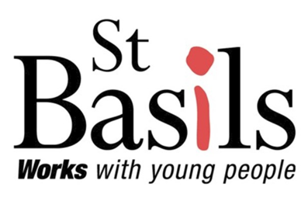
ST BASILS
St Basils is a homeless shelter in Bromsgrove.
It works with young people aged 16-25 who are homeless or at risk, helping almost 4000 youngsters per year across the West Midlands.

Thank you very much for your continued support of the Community Café and Ramble Group; the fellowship and fundraising are instrumental in raising money for St Basils.

FOR YOUR PRAYERS:

Trevor Betteridge, Margaret Woodgates, Rhoda.

The Christian Union at South Bromsgrove High School
Please pray for the youngsters and for the termly online prayer meetings that are held to support the school.
Please include our schools – first, middle and high – in our prayers.

ALL SAINTS’

CHATTERY
Meetings are held weekly on Wednesdays in All Saints’ Church Hall from 2.00 to 3.30 pm.
It is a warm, friendly group of a wide range of ages. Further details from Tessa Carrick on 01527 873135.

CHOIR PRACTICES: Most weeks the choir rehearsals are on Thursdays from 5.30 pm to 7.00 pm.
Members of the Choir are asked to be at church on 2nd, 3rd and 4th Sundays by 9.50 am for practice before the 10.30 am services. Please contact Ollie Neale regarding the choir and music and to confirm times of practices: ollie.neale@hotmail.co.uk

If you enjoy listening to All Saints’ Choir at Services you might like to see this schedule:

1st Sunday of the month: The Choir join the 10.30am Joint Service at St Godwald’s, Holy Communion with Hymns, (with organist Joel Pagett)
2nd Sunday of the month: 10.30am Joint Service at All Saints’ with St Godwald’s. The 'Main' Choral Service of the month where we might have a more complex Anthem/Service Music etc.
3rd Sunday of the month: 10.30am Lay-Led Service-only Hymns.
4th Sunday of the month: 10.30am Holy Communion-Mass Setting, Anthem and Hymns.
5th Sunday of the month: 10.00am Team Service ONLY if at All Saints’ Church


MOTHERS’ UNION
The Mothers’ Union will meet on the third Monday of each month at 2.30pm at 12, Chapel Street, Bromsgrove. At each meeting there is a short time of worship, a speaker and refreshments. All are welcome.

ALL SAINTS’ ANNUAL REPORT
Please send contributions by WORD to
crawleypamela@hotmail.com by March 10th
Thank you
Pam Rosewarne

ELECTORAL ROLL
This is a big year for the Church Electoral Roll! Every 6 years we have to ‘start again’, it doesn’t matter who was on the roll previously, everyone is taken off, and everyone has to re-apply.
Please return your completed forms to Tessa Carrick.

UPDATE ON POSTAGE STAMPS - THANK YOU AND PLEASE KEEP SAVING THEM!

This is an ongoing initiative and so please can you still continue to save them. Stamps can be brought to church during any of our services, there is a clearly marked box on the table at the back, or to the Parish Office, during opening hours, where there is a box for them. There is no cost to the church for sending these to the RNIB (Royal National Institute of Blind People), and is a really good way of recycling our stamps and raise money for the RNIB - £20.00 per kilo.
Thank you very much. If you have any queries about this, then please call Gill Gould (All Saints on 07824368584).


THE BASEMENT PROJECT
Please remember to keep supporting the Basement Project.
More information at
www.basementproject.org.

DATES for your DIARIES

Saturday 22nd March: Friends of St Godwald Concert.

Sunday 1st June: Friends of St Godwald Patronal Festival.

Saturday 7th June: St Godwald’s Summer Fair.

Saturday 12th July: Friends of St Godwald
“Strawberry Tea and Plant Sale”
2.00 - 4.00pm in St Godwald’s Church Hall

Wednesday 30th July: All Saints’ Cream Tea at 2.00 pm
Tickets £5.00 more details later

Saturday 13th September: Heritage Weekend at All Saints’ – more
Sunday 14th September: details later

Saturday 29th November: All Saints’ Christmas Bazaar will be taking
place on from 2.00 pm to 4.00 pm in the Church Hall.

MONTHLY PATTERN of SERVICES at All Saints’ and St Godwald’s:

1st Sunday: 8.00 am Holy Communion CW at All Saints’
10.30am Joint Holy Communion CW at St Godwald’s

2nd Sunday: 9.00am Holy Communion BCP at St Godwald’s
10.30 am Joint Holy Communion CW at All Saints’

3rd Sunday: 8.00 am Holy Communion CW at All Saints.
10.30am Holy Communion CW at St Godwald’s
10.30 am Morning Worship at All Saints'.

4th Sunday: 9.00 am Holy Communion BCP at St Godwald's
10.30 am Holy Communion CW at All Saints’.
10.30 am Morning Worship at St Godwald's.

5th Sunday: Team Service in various churches.

First Saturday: 5.00pm Soul and Sense at All Saints’
Last Saturday: 5.00pm Café/Pizza Church at St Godwald’s

St Godwald’s and All Saints’ Services for MARCH:

Saturday 1st March:
5.00 pm All Saints’: Soul and Senses Service led by Rev’d Debra Buckley and Gill Gould

Sunday 2nd March: Sunday next before Lent
8.00 am All Saints’: Said Holy Communion (CW) led by Rev’d Sue Humphries.
10.30 am St Godwald’s: Joint Holy Communion (CW) with All Saints’ led by Rev’d Ann Cogle

Wednesday 5th March: Ash Wednesday
10.00am St Godwald’s: Holy Communion and Imposition of Ashes led by Rev’d Ann Cogle

Sunday 9th March: Lent 1
9.00 am St. Godwald’s: Holy Communion (BCP) led by Rev’d Ann Cogle
10.30 am All Saints’: Joint Holy Communion (CW) with St Godwald’s led by Fr David Lingwood

Sunday 16th March: Lent 2
8.00 am All Saints’: Said Holy Communion led by Rev’d Sue Humphries.
10.30 am St. Godwald’s: Holy Communion (CW) led by Rev’d Ann Cogle
10.30 am All Saints’: Morning Worship - led by Pam Rosewarne and Sue Ward.

Sunday 23rd March: Lent 3
9.00 am St. Godwald’s: Holy Communion (BCP) led by Rev’d Deb Buckley
10.30 am St Godwald’s: Morning Worship led by Judith Rowe and Emma Morris
10.30 am All Saints’: Holy Communion (CW) led by Rev’d Deb Buckley

Sunday 30th March: Lent 4 - Mothering Sunday
10.30 am St. Godwald’s: All-age Service with Holy Communion (CW) led by Rev’d Ann Cogle
10.30 am All Saints’: Service for Mothering Sunday led by Rev’d Deb Buckley

CONTACT DETAILS:

Lauren Jones – Parish Administrator
(For all enquiries including the booking of Church Halls)
St Godwald’s Office:
01527 577759
pa.bromsgroveparish@gmail.com
Working hours: Monday, Tuesday and Thursday from 9.30am-2.30pm.

All Saints’ Church Wardens:
Sue Ward 0121 453 3180 and Sue Bryant 01527 835728
St Godwald’s Church Wardens:
Caroline Spencer 01527 832414 and Norman Hewer 01527 871722

All Saints’ Organist and Choirmaster
Ollie Neale, email: ollie.neale@hotmail.co.uk

SAFEGUARDING
All Saints’ Safeguarding Lead:
Gill Gould 07824 368584
St Godwald’s Safeguarding Lead:
Catherine Maund 07788 418045
Diocesan Safeguarding Advisor:
Hilary Higton 07495 060869

The Diocese of Worcester, All Saints DCC and St Godwald’s DCC are all committed to promoting a Safer Church for everyone. We will seek to promote the welfare of children, young people and adults, work to prevent abuse from occurring, protect those that are at risk of being abused, and respond well to those that have experienced abuse.

***Information for the Newsletter:
Please let me have any news or items for the next Newsletter from either St Godwald’s or All Saints’ by 12 noon on Tuesday, 25th March, Thank you, Catherine Maund: cmaund1@sky.com

