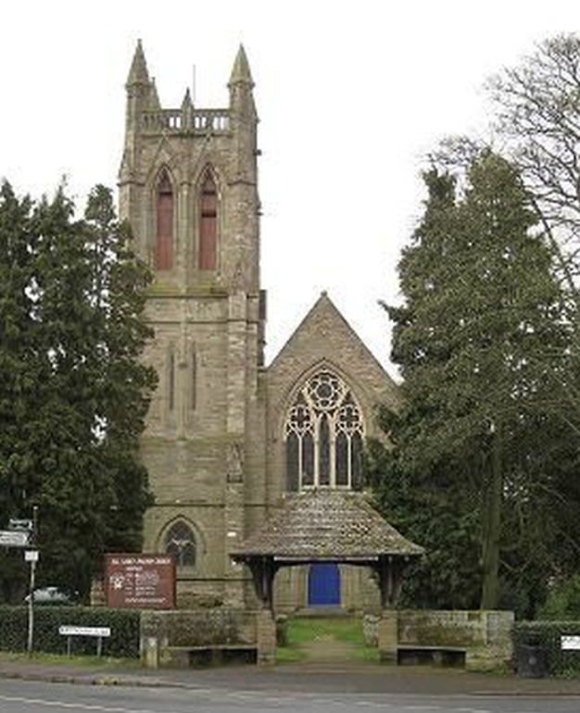
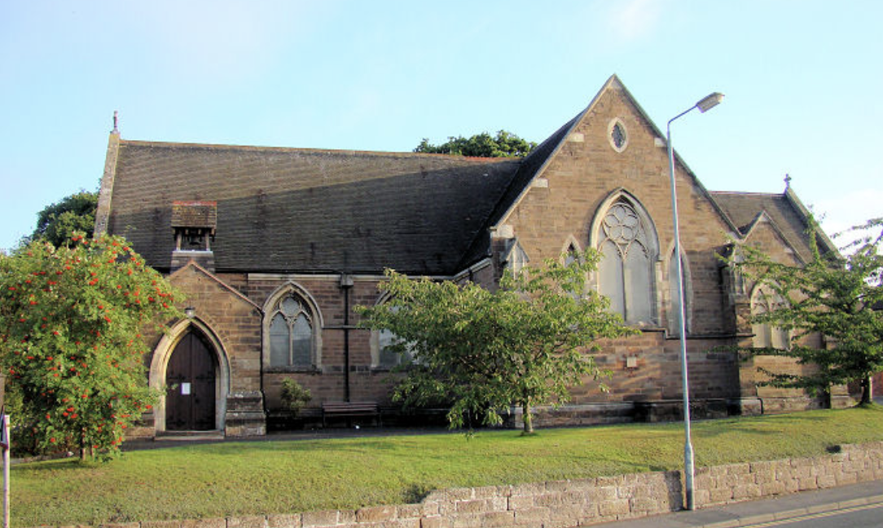
ALL SAINTS’ AND ST GODWALD’S

SUNDAY 27th OCTOBER 2024
Last Sunday after Trinity

Prayer for the Week
Merciful God,
teach us to be faithful in change and uncertainty,
that trusting in your word
and obeying your will
we may enter the unfailing joy of Jesus Christ our Lord.

Saturday 26th October:
5.00 pm St Godwald’s Café/Pizza Church led by Kerstin MacDonald

Sunday 27th October: Trinity 22 Last Sunday after Trinity
9.00 am St. Godwald’s: Holy Communion (BCP)
10.30 am St Godwald’s: Morning Worship led by Emma Morris and Judith Rowe
10.30 am All Saints’: Holy Communion (CW)
Unfortunately this service will not zoomed.
6.00 pm Evening Gathering on Zoom led by Rosemary Sumner.
Zoom ID: 625 582 5148

Next Week’s Services:
Saturday 2nd November:
5.00 pm All Saints’: Soul and Senses Service led by Rev’d Deb Buckley and Gill Gould

Sunday 3rd November: 4th Sunday Before Advent
8.00 am All Saints’: Said Holy Communion (CW) led by Rev’d Sue Humphries.
10.30 am St. Godwald’s: Joint Holy Communion (CW) with All Saints’ led by Rev’d David Lingwood
4.00 pm St Godwald’s: All Souls’ Service – more detail further in the Newsletter
4.00 pm All Saints’: All Souls’ Service – more detail further in the Newsletter
6.00 pm Evening Gathering on Zoom led by Tessa Carrick.

SUNDAY @ 6 - EVENING GATHERING on ZOOM
At 6pm each Sunday on Zoom there is a short service (Compline, Celtic or Evensong) which can include prayers, meditation, visuals and music. The theme varies with the contributor. All are welcome to join our friendly little group!

SOUL AND SENSES SERVICE
This is a Service at All Saints’ Church held on the first Saturday of each month. The next service is on Saturday 2nd November 2024. Each Service starts at 5.00pm and lasts for around 40 minutes.
Please come and join us in wondering and exploring what God is saying to and with us. ALL are welcome - come as you are!

PIZZA (CAFÉ) CHURCH
Café Church is an informal service in the Church Hall at St. Godwald's for all the family to enjoy. A small buffet style supper is included. The next Pizza Church is on Saturday, October 26th at 5pm (and every last Saturday of the month).

Fr DAVID LINGWOOD
Fr David Lingwood's sermons, including last week’s at St Godwald’s, are available online at:
www.youtube.com/@Fr.David.TSSF-HorribleHomilies/videos
or by searching for 'Horrible Homilies' on YouTube.
Each is about 7 minutes long and is a multimedia presentation.

ALL SAINTS’


The WEEKLY CHATTERY MEETINGS are in the Church Hall.

Informal meetings are held weekly on Wednesdays in All Saints’ Church Hall from 2.00 to 3.30 pm.
Everyone is welcome to join the chatting and to enjoy a hot drink. You can also join in quizzes, board games or jigsaws if you wish.
It is a warm, friendly group of a wide range of ages. Further details from Tessa Carrick on 01527 873135.

CHOIR PRACTICES: Most weeks the choir rehearsals are on Thursdays from 5.30 pm to 7.00 pm.
Members of the Choir are asked to be at church on 2nd, 3rd and 4th Sundays by 9.50 am for practice before the 10.30 am services. Please contact Ollie Neale regarding the choir and music and to confirm times of practices: ollie.neale@hotmail.co.uk

If you enjoy listening to All Saints’ Choir at Services you might like to see this schedule:

1st Sunday of the month: The Choir join the 10.30am Joint Service at St Godwald’s, Holy Communion with Hymns, (with organist Joel Pagett)
2nd Sunday of the month: 10.30am Joint Service at All Saints’ with St Godwald’s. The 'Main' Choral Service of the month where we might have a more complex Anthem/Service Music etc.
3rd Sunday of the month: 10.30am Lay-Led Service-only Hymns.
4th Sunday of the month: 10.30am Holy Communion-Mass Setting, Anthem and Hymns.
5th Sunday of the month: 10.00am Team Service ONLY if at All Saints’ Church


MOTHERS’ UNION
The Mothers’ Union will meet on the third Monday of each month at 2.30pm at 12, Chapel Street, Bromsgrove. At each meeting there is a short time of worship, a speaker and refreshments. All are welcome.


THE BASEMENT PROJECT

Help needed for The Basement Project
As we head into the autumn, we would like to invite you to support local Bromsgrove charity, The Basement Project, which All Saints’ have a history of supporting.

What is The Basement Project?
The Basement Project is an independent local charity that offers support and guidance to young people (under 25 years of age) experiencing issues or difficulties. The charity helps those who are homeless or facing homelessness, including support “aligned to resolving financial challenges, relationship issues”. They support a journey to independence through education, employment and training.

How can I support?
Located at the back of All Saints’ Church is a box to receive small donations for The Basement Project, based here in Bromsgrove. If you are able to contribute a small item (food items, toiletries or £1/£2) once or twice a month, our collective effort will enable us to regularly contribute to food and toiletry parcels for use by young people in need.

What can I donate?
Any store cupboard food or drink item that has a reasonable best before date. Toiletries are also welcomed. If you would prefer, feel free to pop £1 or £2 in the box and we’ll convert it to food and toiletries.

Thank you
Thank you if you are already a supporter of The Basement Project and thank you if you are able and willing to start supporting. More information at www.basementproject.org.

ST GODWALD’S

MONDAY 28thOCTOBER - No Totwalds today due to half term holiday!
Totwalds is our worship time in church for 0-5 year-olds and their parents/carers. There is always a story, lovely songs and an activity.
Everyone is welcome at 9.30am each Monday morning.

TUESDAY WALKS meet on 2nd and 4th Tuesdays.
Please note that the next walk is on 12th November 2024 at 10.00 am starting from the Ruth Heald Room and returning at 12 noon for refreshments.

WEDNESDAY MORNING SERVICE
Join us in the Ruth Heald Room at 10.00 am for Worship followed by refreshments.
There will be one Communion Service each month and three services of Morning Worship.


ST GODWALD’s COMMUNITY CAFÉ:
The Community Café is open every alternate Friday. The next café will be Friday 25th October 2024 10.00 am until 12 noon.
No charge but donations always very welcome.

REV’D ANN COGLE
Please remember and pray for the Rev’d Ann Cogle and her family as they move house from Reading to a temporary location in Stourport, and to welcome them to Bromsgrove.

SAMARITANS PURSE - Operation Christmas Child Shoe Box Appeal 2024 - We will be supporting this appeal again this year; the boxes are available in the Church and in the Ruth Heald Room. National collection week will be in November. So, if you can start collecting gifts for the boxes now, there will be a filler list available in church for you to take away. Please ring Jan Hewer if you have a problem in finding one (07813 170 734).
Many thanks, Jan Hewer

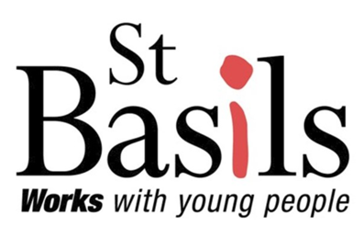
ST BASILS
St Basils is a homeless shelter in Bromsgrove.
It works with young people aged 16-25 who are homeless or at risk, helping almost 4000 youngsters per year across the West Midlands.

St Godwald’s Church has supported St Basils for many years. For example, 12 years ago Judith and David opened a Community Café, which still runs on alternate Fridays.
The café is very popular with the local community, with many friendships being made; there are always homemade cakes, tea and coffee available to anyone who pays a visit. We have always had a donation policy rather than an individual payment. This has allowed us to give St Basils a £50.00 donation each month. The money is a backup for the youngsters, most of them arriving with nothing: bus fares, phone top ups, new shoes are just a few of the things that this cash allows St Basils to support.

Likewise, the Tuesday Ramble has attracted people from the local community and after our walk, scones, cake, tea and coffee are offered, again paid for by donation.

Each Christmas, again thanks to donations, every youngster receives a Christmas present, beautifully put together by Judith and David’s daughter Emma; this kindness has made an awful lot of difference to these young people.

Any surplus money from these two ventures is given to other charities supported by St Godwald’s. A lump sum is often given to St Basils to enable them to give the youngsters a treat, a pizza night or a cinema visit.

Thank you very much for supporting the Community Café and Ramble Group in all sorts of ways; new faces are always welcome to join in our fellowship and fundraising.

DATES FOR YOUR DIARY

Sunday 3rd November at 4.00pm – there will be All Souls’ Services at BOTH St Godwald’s Church and All Saints’ Church

A special Service of Thanksgiving and Remembrance will be held on Sunday 3rd November at 4.00pm. during which we read out the names of those who have died and light candles in their memory.

There is a list at the back of the Church to write the name of your loved one you wish to remember and to light a candle. If you know of anyone else who would like their relative or friend remembered in this way at the Service, please extend this invitation to them.


Saturday 30th November: All Saints’ Christmas Bazaar - In the Church Hall.
It will soon be time for this popular event and to make it a success we need donations for our stalls, including, Cakes, Jams & Chutney, Tombola, Fancy Goods, Raffle and Bottle stall.
Also we are asking for bottle gift bags. Donations will be greatly appreciated and can be brought to church any Sunday, during the services, or to the Church Hall on any Wednesday between 2.00 - 3.30pm.
Thank you very much and we look forward to seeing you at the Bazaar, book the date, Saturday 30th November at 2pm - 4pm and look out for more publicity over the coming week.

FOR YOUR PRAYERS:

Trevor Betteridge

The Christian Union at South Bromsgrove High School
Please pray for the youngsters and for the emergence of appropriate adult leadership. Please pray too for the termly online prayer meetings that are held to support the school.
Please include our schools – first, middle and high – in our prayers.

St Godwald’s and All Saints’ Services for the remainder of NOVEMBER:

Saturday 2nd November:
5.00 pm All Saints’: Soul and Senses Service led by Rev’d Deb Buckley and Gill Gould

Sunday 3rd November: 4th Sunday Before Advent
8.00 am All Saints’: Said Holy Communion (CW) led by Rev’d Sue Humphries.
10.30 am St. Godwald’s: Joint Holy Communion (CW) with All Saints’ led by Rev’d David Lingwood
4.00 pm St Godwald’s: All Souls Service
4.00 pm St Godwald’s: All Souls Service
6.00 pm Evening Gathering on Zoom led by Tessa Carrick.

Sunday 10th November: REMEMBRANCE SUNDAY
10.30 am St. Godwald’s: Remembrance Service led by Jan Hewer.
10.30 am All Saints’: Remembrance Service with Holy Communion (CW) led by Rev’d Deb Buckley
6.00 pm Evening Gathering on Zoom led by Rosemary Sumner

Sunday 17th November: 2nd Sunday Before Advent
8.00 am All Saints’: Said Holy Communion led by Rev’d Sue Humphries.
10.30 am St. Godwald’s: Holy Communion (CW) led by the Bishop of Dudley.
10.30 am All Saints’: Morning Worship - led by Pam Rosewarne and Sue Ward.
6.00 pm Evening Gathering on Zoom.

Sunday 24th November: Christ the King
9.00 am St. Godwald’s: Holy Communion (BCP)
10.30 am St Godwald’s: Morning Worship led by Emma Morris and Judith Rowe
10.30 am All Saints’: Holy Communion (CW)
6.00 pm Evening Gathering on Zoom led by Rosemary Sumner.

Saturday 30th November:
5.00 pm St Godwald’s Café/Pizza Church led by Kerstin MacDonald

MONTHLY PATTERN of SERVICES at All Saints’ and St Godwald’s:

1st Sunday: 8.00 am Holy Communion CW at All Saints’
10.30am Joint Holy Communion CW at St Godwald’s
6.00 pm Evening Gathering on Zoom

2nd Sunday: 9.00am Holy Communion BCP at St Godwald’s
10.30 am Joint Holy Communion CW at All Saints’
6.00 pm Evening Gathering on Zoom.

3rd Sunday: 8.00 am Holy Communion CW at All Saints.
10.30am Holy Communion CW at St Godwald’s
10.30 am Morning Worship at All Saints'.
6.00 pm Evening Gathering on Zoom

4th Sunday: 9.00 am Holy Communion BCP at St Godwald's
10.30 am Holy Communion CW at All Saints’.
10.30 am Morning Worship at St Godwald's.
6.00 pm Evening Gathering on Zoom.

5th Sunday: Team Service in various churches.

First Saturday: 5.00pm Soul and Sense at All Saints’
Last Saturday: 5.00pm Café/Pizza Church at St Godwald’s

CONTACT DETAILS:

Lauren Jones – Parish Administrator
(For all enquiries including the booking of Church Halls)
St Godwald’s Office:
01527 577759
pa.bromsgroveparish@gmail.com
Monday, Tuesday and Thursday from 9.30am-2.30pm.

All Saints’ Church Wardens:
Sue Ward 0121 453 3180 and Sue Bryant 01527 835728
St Godwald’s Church Wardens:
Caroline Spencer 01527 832414 and Norman Hewer 01527 871722

All Saints’ Organist and Choirmaster
Ollie Neale, email: ollie.neale@hotmail.co.uk

All Saints’ Safeguarding Lead:
Gill Gould 07824 368584
St Godwald’s Safeguarding Lead:
Catherine Maund 07788 418045
Diocesan Safeguarding Advisor:
Hilary Higton 07495 060869

Information for the Newsletter:
Please let me have any news or items for next week’s Newsletter from either St Godwald’s or All Saints’ by 12 noon on Tuesday, Thank you, Catherine Maund: cmaund1@sky.com

