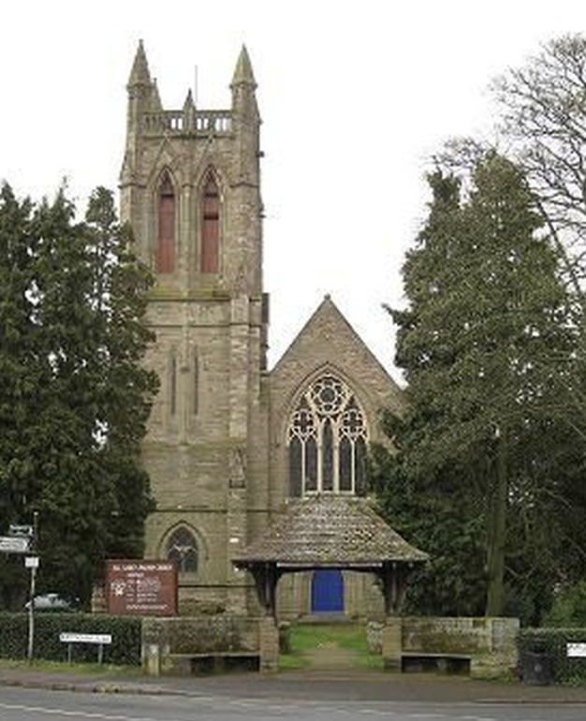
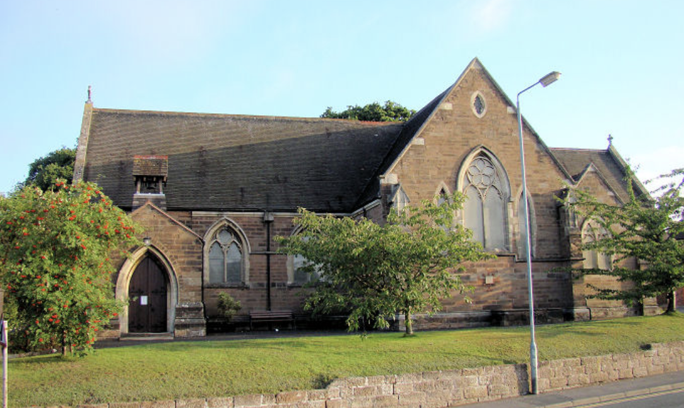
ALL SAINTS’ AND ST GODWALD’S
SUNDAY 18th AUGUST 2024
Twelfth Sunday after Trinity

Prayer for the Week
God of constant mercy,
who sent your Son to save us:
remind us of your goodness,
increase your grace within us,
that our thankfulness may grow,
through Jesus Christ our Lord.

Sunday 18th August: Trinity 12
8.00 am All Saints’: Said Holy Communion led by Rev’d Sue Humphries.
10.30 am St. Godwald’s: Holy Communion (CW) led by Rev’d Nikki Groake, Archdeacon
Unfortunately, this service will not be available via Zoom.
10.30 am All Saints’: Morning Worship - led by Pam Rosewarne and Marjorie Carnelly.
6.00 pm Evening Gathering on Zoom led by Rosemary Sumner.
Zoom ID: 625 582 5148

Next Week’s Services:
Sunday 25th August: Trinity 13
9.00 am St. Godwald’s: Holy Communion (BCP) led by Rev’d Sue Humphries.
10.30 am St Godwald’s: Morning Worship led by Emma Morris and Judith Rowe
10.30 am All Saints’: Holy Communion (CW) led by Rev’d Deb Buckley
6.00 pm Evening Gathering on Zoom led by Rosemary Sumner.

Saturday 31st August:
5.00 pm St Godwald’s Café/Pizza Church led by Kirsten MacDonald

SUNDAY @ 6 - EVENING GATHERING on ZOOM
At 6pm each Sunday on Zoom there is a short service (Compline, Celtic or Evensong) which can include prayers, meditation, visuals and music. The theme varies with the contributor. All are welcome to join our friendly little group!

SOUL AND SENSES SERVICE
This is a Service at All Saints’ Church held on the first Saturday of each month. There will not be a service in July, the next service is on Saturday 7th September 2024. Each Service starts at 5.00pm and lasts for around 40 minutes.
Please come and join us in wondering and exploring what God is saying to and with us. ALL are welcome - come as you are!

PIZZA (CAFÉ) CHURCH
Café Church is an informal service in the Church Hall at St. Godwald's for all the family to enjoy. A small buffet style supper is included. The next Pizza Church is on Saturday, August 31st at 5pm (and every last Saturday of the month).

Fr DAVID LINGWOOD
Fr David Lingwood's sermons are now available online at www.youtube.com/@Fr.David.TSSF-HorribleHomilies/videos
or by searching for 'Horrible Homilies' on YouTube.
Each is about 7 minutes long and is a multimedia presentation.


ALL SAINTS’

The WEEKLY CHATTERY MEETINGS are in the Church Hall.

Informal meetings are held weekly on Wednesdays in All Saints’ Church Hall from 2.00 to 3.30 pm.
Everyone is welcome to join the chatting and to enjoy a hot drink. You can also join in quizzes, board games or jigsaws if you wish.
It is a warm, friendly group of a wide range of ages. Further details from Tessa Carrick on 01527 873135.

CHOIR PRACTICES: Most weeks the choir rehearsals are on Thursdays from 5.30 pm to 7.00 pm.
Members of the Choir are asked to be at church on 2nd, 3rd and 4th Sundays by 9.50 am for practice before the 10.30 am services. Please contact Ollie Neale regarding the choir and music and to confirm times of practices: ollie.neale@hotmail.co.uk


MOTHERS’ UNION
The Mothers’ Union will meet on the third Monday of each month at 2.30pm at 12, Chapel Street, Bromsgrove. At each meeting there is a short time of worship, a speaker and refreshments. All are welcome.
NB – THERE IS NO MEETING ON TUESDAY 19th AUGUST

ST GODWALD’S

ST GODWALD’S VICARAGE
During the interregnum, we are obliged by the diocese to maintain the garden in good order.
Weather permitting, please arm yourselves with the necessary small tools - trowels, hand or border forks, secateurs, shears, strimmers and fruit picking equipment - for a working party on Saturday 24 August from 10.00am onwards.

TOTWALDS
Totwalds is our worship time in church for 0-5 year-olds and their parents/carers. There is always a story, lovely songs and an activity.
Everyone is welcome at 9.30am each Monday morning.
Totwalds is now enjoying the Summer break; back again in September!

TUESDAY WALKS meet on 2nd and 4th Tuesdays.
Please note that the next walk is on 27th August 2024 at 10.00 am starting from the Ruth Heald Room and returning at 12 noon for refreshments.

WEDNESDAY MORNING SERVICE
Join us in the Ruth Heald Room at 10.00 am for Worship followed by refreshments.
There will be one Communion Service each month and three services of Morning Worship.


ST GODWALD’s COMMUNITY CAFÉ:
The Community Café is open every alternate Friday. The next café will be Friday 16th August 2024 10.00 am until 12 noon.

No charge but donations always very welcome

DATES FOR YOUR DIARY

Saturday 7th September: Heritage Weekend at All Saints’ Church
Saturday 30th November: All Saints’ Christmas Bazaar

FOR YOUR PRAYERS:

Pat Cattell
Kath Pitt

The Christian Union at South Bromsgrove High School
Please pray for the youngsters and for the emergence of appropriate adult leadership. Please pray too for the termly online prayer meetings that are held to support the school.
Please include our schools – first, middle and high – in our prayers.

CHURCH REGISTERS

BAPTISMS:
Harley Grayson Mark Ford - 4th August (St Godwald’s)
Eliana-Grey Kallie Vollrath - 4th August (St Godwald’s)

WEDDINGS:
Heather Clunie and Ben Doolan - 21st September (St Godwald’s)

FROM DAVID AND LIZ

Greetings from Wirksworth! A huge ‘thank you’ to everyone for all your cards, emails, gifts and all the messages conveyed. We have felt very loved these past weeks. It is taking a little time to adapt to a different routine – there isn’t one! – helped enormously by some lovely weather and many tasks to be done. We feel very blessed to live in a beautiful small town surrounded by amazing walking country without the need to get in the car. Your generosity was amazing and the accompanying photos illustrate this. The vine was given by Pizza Church and sits in one of several new pots purchased with a garden voucher from All Saints. This is in our back porch which gets lots of afternoon sun and should see the vine thrive in years to come. The olive tree was a gift from St Godwald’s and sits in a Whichford pot in the corner of our back yard beneath the garden. We’ve had the pot since we lived near Whichford in Oxfordshire 20 years ago but we’ve never fully used it – until now! Next month we will have a boating holiday on the Broads funded by the main gift from all the churches. Norfolk means a lot to both of us and we’ve never had a boating holiday there. We look forward to that enormously and will think of you all much that week. We will keep in touch from time to time and wish you all every blessing as you await your next Rector. With love, prayers and heartfelt thanks, David and Liz xx
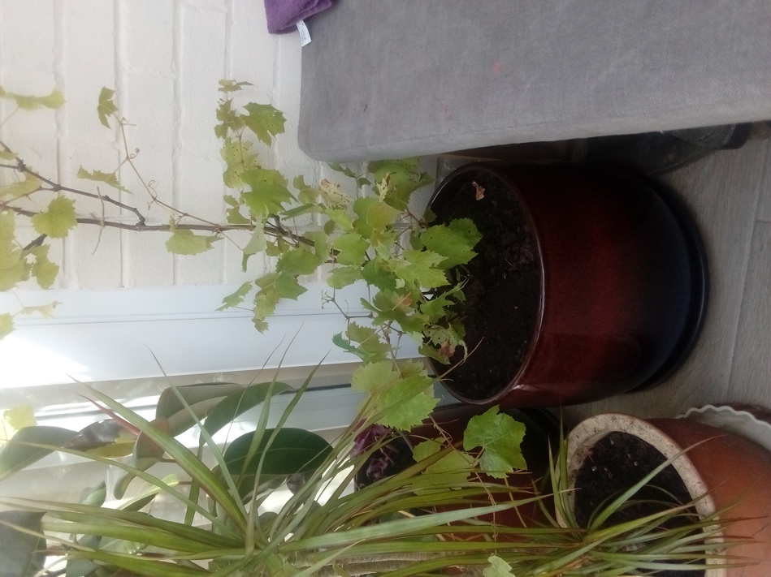 | 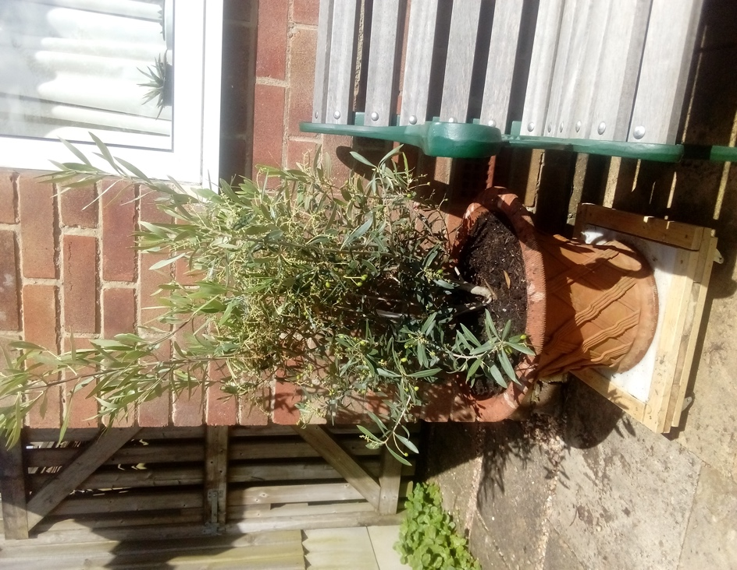

St Godwald’s and All Saints’ Services for AUGUST:

Saturday 3rd August:
5.00 pm All Saints’: Soul and Senses Service led by Rev’d Deb Buckley and Gill Gould

Sunday 4th August: Trinity 10
8.00 am All Saints’: Said Holy Communion (CW) led by Rev’d Sue Humphries.
10.30 am St. Godwald’s: Joint Holy Communion (CW) with All Saints’ led by Rev’d David Lingwood
6.00 pm Evening Gathering on Zoom led by Tessa Carrick.

Sunday 11th August: Trinity 11
9.00 am St. Godwald’s: Holy Communion (BCP) led by Rev’d Sue Humphries.
10.30 am All Saints’: Joint Holy Communion (CW) with St Godwald’s
6.00 pm Evening Gathering on Zoom led by Rosemary Sumner

Sunday 18th August: Trinity 12
8.00 am All Saints’: Said Holy Communion led by Rev’d Sue Humphries.
10.30 am St. Godwald’s: Holy Communion (CW) led by Rev’d Nikki Groake, Archdeacon
10.30 am All Saints’: Morning Worship - led by Pam Rosewarne and Sue Ward.
6.00 pm Evening Gathering on Zoom led by Judith Rowe.

Sunday 25th August: Trinity 13
9.00 am St. Godwald’s: Holy Communion (BCP) led by Rev’d Sue Humphries.
10.30 am St Godwald’s: Morning Worship led by Emma Morris and Judith Rowe
10.30 am All Saints’: Holy Communion (CW) led by Rev’d Deb Buckley
6.00 pm Evening Gathering on Zoom led by Rosemary Sumner.

Saturday 31st August:
5.00 pm St Godwald’s Café/Pizza Church led by Kirsten MacDonald

CONTACT DETAILS:

Lauren Jones – Parish Administrator
(For all enquiries including the booking of Church Halls)
St Godwald’s Office:
01527 577759
pa.bromsgroveparish@gmail.com
Monday, Tuesday and Thursday from 9.30am-2.30pm.
Lauren will be annual leave 19th – 30th August

All Saints’ Church Wardens:
Sue Ward 0121 453 3180 and Sue Bryant 01527 835728
St Godwald’s Church Wardens:
Caroline Spencer 01527 832414 and Norman Hewer 01527 871722

All Saints’ Organist and Choirmaster
Ollie Neale, email: ollie.neale@hotmail.co.uk

All Saints’ Safeguarding Lead:
Gill Gould 07824 368584
St Godwald’s Safeguarding Lead:
Catherine Maund 07788 418045

Diocesan Safeguarding Advisor:
Hilary Higton 07495 060869

Information for the Newsletter:
Please let me have any news or items for next week’s Newsletter from either St Godwald’s or All Saints’ by 12 noon on Tuesday, Thank you, Catherine Maund: cmaund1@sky.com

