


Sermon for Trinity 4 Sunday 5th July 2020

To what are you Yoked?

“To what can I compare this generation? They are like children sitting in the marketplaces and calling out to others:

“‘We played the pipe for you,
and you did not dance;
we sang a dirge,
and you did not mourn.’

For John came neither eating nor drinking, and they say, ‘He has a demon.’ The Son of Man came eating and drinking, and they say, ‘Here is a glutton and a drunkard, a friend of tax collectors and sinners.’ But wisdom is proved right by her deeds.”

At that time Jesus said, “I praise you, Father, Lord of heaven and earth, because you have hidden these things from the wise and learned, and revealed them to little children. Yes, Father, for this is what you were pleased to do.

“All things have been committed to me by my Father. No one knows the Son except the Father, and no one knows the Father except the Son and those to whom the Son chooses to reveal him.

“Come to me, all you who are weary and burdened, and I will give you rest. Take my yoke upon you and learn from me, for I am gentle and humble in heart, and you will find rest for your souls. For my yoke is easy and my burden is light.”

I’m sure you’ve noticed how some people are predisposed in life to be ‘moaners’. They moan when things go well – and they moan when they don’t. No amount of placating, nurturing, accommodating, will work. It is quite impossible to satisfy them.

At the beginning of our gospel reading Jesus hones in on those who found fault with John the Baptist for his ascetism and now find fault with Jesus for his feasting and partying. There is simply no way of pleasing them. Jesus is surrounded by some of life’s moaners who cannot see the good in anything, but are swift to spot the weakness in everything. It’s hardly surprising that we have Jesus’ sayings about shaking the dust off one’s feet or spotting the plank in one’s eye before spotting the speck in another’s. Jesus understands human frailty completely.

One of the positives of the COVID19 pandemic that we all mention frequently has been the outpouring of love and service that has breathed new life into so many of our communities throughout the country including here in Bromsgrove. During these past few months many have lived the truth of Jesus’ declaration that “wisdom is justified by her deeds”. Through this terrible pandemic, the Kingdom of God has drawn near to many who – though they may not have recognised it for what it is – have, through giving to others or receiving from others, been touched by the gift of God’s love and grace. For a short time, in the midst of tragedy and great sadness, even many of life’s moaners have been silenced by love and grace.

Yet in the past week and over this weekend we’ve already seen how easily these signs of the Kingdom can start to disintegrate. There is a real chance that much of the good seed spread around our communities these past months will have fallen on stony ground or been choked by the weeds of selfishness that have so swiftly sprung up as lockdown has eased.

How can we ensure that some of the good evident these past months lasts for ever?

People are motivated to acts of generosity for all sorts of reasons, some of which at times are quite superficial, some of which are held very deeply and personally. Some volunteers these past months have been swept along with the communal tide of goodwill; others because they’ve had more time on their hands than usual; others, because they have been affected by tragedy and simply wish to give back.

Those motivated by their faith – Christian or otherwise – are amongst the most resilient givers of all. For their faith is not simply the source of their motivation, but the source of their sustenance too.

And this thought brings me to the final paragraph of our gospel reading:

“Come to me, all you who labour and are overburdened, and I will give you rest. Shoulder my yoke and learn from me, for I am gentle and humble in heart, and you will find rest for your souls. Yes, my yoke is easy and my burden is light.”

In preparation for today’s sermon, I suggested you consider the following question: to what are you yoked?

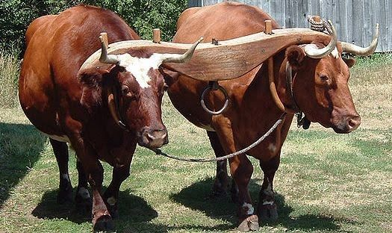
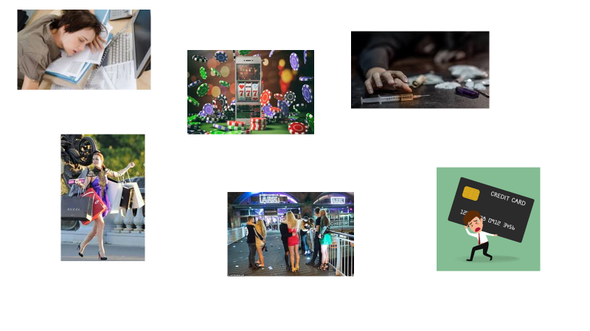
Well that is a very personal question, of course. But here are some more images that might resonate with you or people you know…

These are amongst the most predictable ‘yokes’ of modern western society; overwork, shopping, drugs, gambling, alcohol, debt and so on. And very many people of all ages and backgrounds get caught up in cycles of behaviour that tighten the yokes around their lives and around the lives of those close to them too.

But there is another kind of yoke too. These are yokes generated by other people’s use of power, opinion or prejudice over us. The yoke of low self-esteem, low educational achievement, the yoke of ambition, the yoke of bullying. These are the yokes we often feel we cannot do much about, and so we find a way to put up with what is unacceptable.

The image I’ve chosen to illustrate all these yokes of other people’s making is difficult to take in but I make no apology for using it.

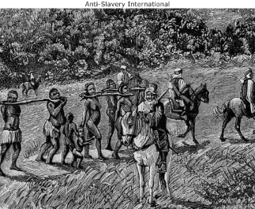

This image of slavery in which people were quite literally yoked to one another, is a painful reminder of part of our nation’s history but also a powerful, metaphorical reminder of the current experience of many Black, Asian and Minority Ethnic people today, not only in our nation, but in our community, in our churches, and for some of us, in our own families too.

Racism is a distinctive example of a yoke, a burden that grinds us down, a barrier to our true selves, an obstacle that limits our horizons, our hopes, our lives – all at our expense for someone else’s benefit.

In Jesus’ day there were two major yokes – the roman occupation with its rules, demands and financial pressures; and the Jewish law also with its rules, demands and financial pressures. It was not an easy life unless you were amongst the religious and political elite. For most people – Jesus describes them as children but means many adults too – life was harsh, dispossessing, limiting and short.

Jesus invites us to replace the yokes of our society and age with his yoke instead. Freedom in Christ is not some kind of libertarian nirvana but a different kind of yoke. Tie yourself to Christ and through Christ the burden of all other yokes will be overcome. Shoulder my yoke, says Jesus, and learn from me.

At a first glance, Jesus’ yoke doesn’t seem very easy to bear. After all, it cost him his life. Your yoke may become your cross. Yet, Jesus insists, my yoke is easy and my burden is light; you can learn from me, after all, I am gentle and humble in heart. In other words, if I can do it, so can you. There is nothing in my gospel, Jesus is saying, that is difficult or beyond your grasp.

Jesus contrasts his yoke with that of the oppressing yoke of Roman occupation and Jewish law. In place of all those really tough regulations that require one to look constantly over one’s shoulder to check that one is doing the right thing, Jesus’ yoke is simplicity itself. Love one another as I have loved you; look after one another, as you would wish to be looked after…

Life doesn’t work as perfectly as this – before or after COVID19 – because of the strength of the stranglehold that our yokes have upon us. These continuous pressures so slowly strangle true life out of us. Despite all the goodness we’ve witnessed these past months, Western society remains on a merciless treadmill towards destruction and along the way relationships are being ripped apart by prejudice, fear, anxiety and pressure of every kind – especially about money.

The irony is that at the heart of our culture is the mistaken belief that the individual has somehow become freer and more independent over time. Nothing could be further from the truth.

Freedom – often confused with choice - is widely misunderstood. Reject the yokes of this world, says Jesus, not in some bid for anarchic freedom, but instead to take on the yoke of Christ.

If your life is dominated by anxiety then I suspect that you have several yokes around your neck, and perhaps the yoke of Christ feels a little smothered at times.

Try to take time this week to think about that; what are your yokes; what are your true anxieties. Take time to pray about it too; ask for God’s guidance to show you how to balance your yokes in a way that is more life giving for you and for those whom you love.

Amen.

